Pulsed Load Analysis
Norbert Doerry
August 1, 2026
- Introduction
A pulse is characterized as a power excursion with a short rise time, a short fall time, and a duration of at least one cycle (for ac applications) and less than 10 seconds (per MIL-STD-1399-300-1 and MIL-STD-1399-300-2). The sudden application of load may result in the system voltage and frequency falling outside of power quality requirements. Additionally, the response of the governor to the pulsed loads on generator set prime movers may result in excessive wear on the prime movers and increased maintenance.
MIL-STD-1399-300-1 characterizes pulsed loads as either infrequent pulsed loads or repetitive pulsed loads. Infrequent pulsed loads occur no more often than once every 120 seconds. A repetitive pulsed load varies more often and may have multiple power levels as depicted in Figure 1.
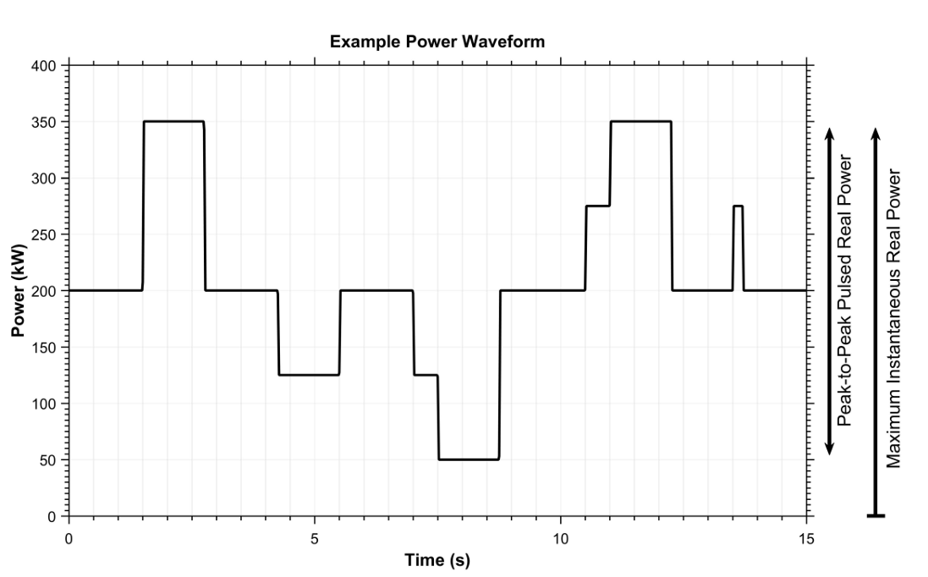
Figure 1: Repetitive Pulsed Load (MIL-STD-1399-300-1)
- Pulsed load requirements
  - Infrequent pulsed load
Infrequent pulsed loads present a pulse no more than once every 120 seconds. Infrequent pulsed loads are limited by MIL-STD-1399-300-1 for 60 Hz power systems to an inrush current to rated current ratio as shown in Figure 2 for low voltage loads and to an inrush current to rated current ratio of 10 for medium voltage loads. The maximum inrush current is assumed to occur only at initial power up; occur in a few milliseconds; and then decay to steady-state values in several more milliseconds to several more seconds. Lower inrush current to current ratios may be required to ensure voltage transient limits are met. Infrequent pulsed loads also have a ramp rate limit of 30% of the online source rating (VA) per second. The minimum source rating could result from a single source, or from paralleled sources depending on the electrical power system concept of operations (EPS-CONOPS) for conditions that include powering the pulsed load.
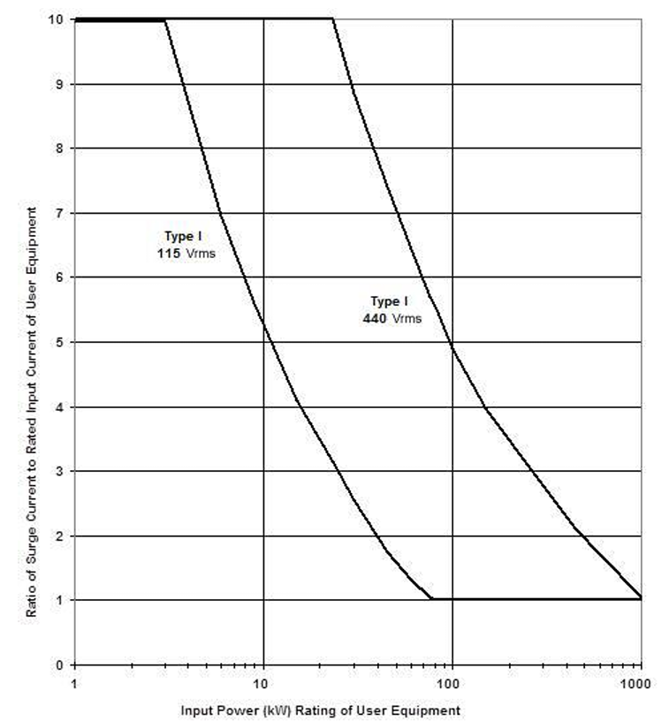
Figure 2: Ratio of Inrush current (surge current) to rated peak current for low voltage loads (MIL-STD-1399-300-1)
  - Repetitive pulsed load
In 60 Hz power systems, repetitive pulsed loads are required by MIL-STD-1399-300-1 to meet the following three requirements:
- Pulsed power deviation limit in the time domain
- Pulsed power magnitude/frequency in the frequency domain
- Power total signal distortion limit.
The pulsed power deviation limit in the time domain is specified in MIL-STD-1399-300-1 as
“5.2.8.1.2.1 Pulsed power deviation limit (time domain). The user equipment shall limit the instantaneous three-phase pulsed real power deviation from the average real power level to be less than ±50 kilowatt (kW) over a 1-second integration interval centered on the event. This requirement applies for loads with a maximum instantaneous real power greater than or equal to 100 kW and less than or equal to 2 megawatt (MW) as seen by the ship’s electric plant. For loads with a maximum instantaneous real power greater than 2 MW, substitute requirements are needed that address the relevant power system’s source impedance and response characteristics of the intended platform for all operating modes. The substitute requirements will be specified in the acquisition documents (see 6.2) and shall have NAVSEA approval (see 6.4). An example showing the ±50 kW pulsed power deviation limit is shown on Figure 3; in this example, the maximum instantaneous real power is 350 kW and the peak-to-peak pulsed real power is 300 kW. The average real power level is determined over a 1-second integration interval centered on the event. This 1-second centered rolling-average power level is calculated on the entire power waveform and is given by the middle dotted line in the graph. The ±50 kW limits are shown by the two bounded dotted lines. Violations of the ±50 kW limits are highlighted in gray.”
The pulsed power deviation limit (time domain) implies that step load changes should be kept less than 100 kW. If the load change of magnitude M kW has a constant ramp rate and is constant for .5 seconds before and after the load change, then for load changes greater than 200 kW the ramp rate should be no more than 400 kW/s; for load changes greater than 100 kW and less than 200 kW, the ramp rate should be no more than $\frac{M^{2}}{M-100}$ kW/s.
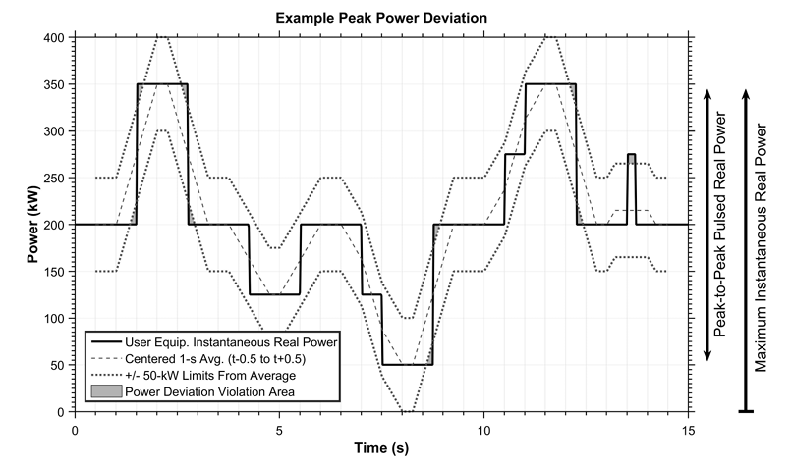
Figure 3: Pulsed power deviation limit in the time domain example (MIL-STD-1399-300-1)
For repetitive pulsed loads with a maximum instantaneous real power greater than 2 MW, establishing system design requirements for the time domain requires detailed transient analysis to ensure power quality requirements are met and that prime movers are not overstressed. These same studies should be performed when integrating all repetitive pulsed loads when sufficient information exists to accurately create dynamic models; the existing criteria do not guarantee all power quality requirements will be met for all systems.
The pulsed power deviation limit in the frequency domain is specified in MIL-STD-1399-300-1 as
“5.2.8.1.2.2 Pulsed power magnitude/frequency limits (frequency domain). The user equipment shall limit the magnitude and frequency of the instantaneous three-phase pulsed real power by the following constraints:
a. This requirement applies to loads with a maximum instantaneous real power level greater than or equal to 100 kW. An absolute limit is also imposed in that the load’s allowed peak-to-peak real pulsed power as defined in 3.10.1 shall be less than or equal to 25 percent of the minimum prime mover real power rating. The window of observation for this limit is over a 100-second window. Pulsed loads with peak-to-peak real pulsed power greater than 25 percent of the minimum prime mover real power rating or greater than 2 MW shall be separately addressed as specified (see 6.2 and 6.4).
b. The repetitive pulsed power magnitude/frequency limits are provided on Figure 4. The plot presents the acceptable zero-to-peak real power magnitude in watts at a given frequency as a percent of the average real power in watts (e.g., at 1 Hz the allowed zero-to-peak real power magnitude is 3 percent of the average load). The zero-to-peak real power magnitude is determined with the average power component removed from the instantaneous power waveform. The average real power is calculated from the instantaneous real power waveform integrated over a 100-second averaging window. To use Figure 4, the instantaneous real power pulsed waveform shall be decomposed into its frequency components after the average real power component has been removed. This is accomplished by using the Discrete Fourier Transform (DFT), incorporating a long window DFT for frequencies below 1 Hz and a short sliding window DFT for frequencies 1 Hz and above.
…
- MIL-STD-1399-300-1 The time for the long window is 100 seconds and the time for the short sliding window is 4 seconds. Each 4-second sliding window shall have a 3-second overlap with the preceding 4-second window.”
MIL-STD-1399-300-1 provides a recommended procedure for performing the DFT. See Boehmer and Temkin (2018) for additional insight on the pulsed power frequency domain limit.
Although not discussed in MIL-STD-1399-300-1, the power component corresponding to the nominal system frequency (60 Hz) should not be required to meet the requirement depicted in Figure 4.
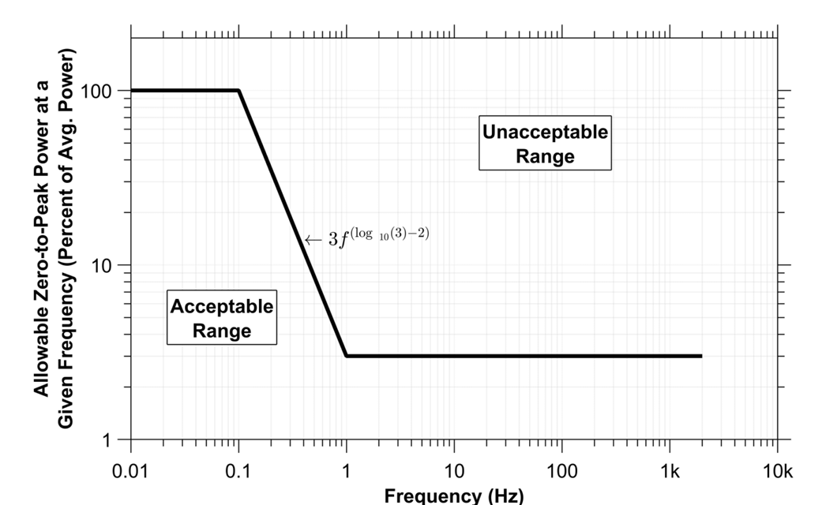
Figure 4: Pulsed power deviation limit in the frequency domain requirement (MIL-STD-1399-300-1)
The Power total signal distortion (TSD) limit (frequency domain) is specified in MIL-STD-1399-300-1 as:
“5.2.8.1.2.3 Power total signal distortion (TSD) limit (frequency domain). For Type I power, the load shall limit the calculated power TSD defined in 3.12 to less than 5 percent for frequencies from 1 Hz to 2 kHz where the average power shall be calculated over a 100-second window. As defined in Appendix A, a TSD calculation on each separate 4-second rolling window DFT is performed. The maximum TSD of all 4-second rolling window DFTs is to be the reported TSD value to be compared against the 5 percent requirement.”
The Power total signal distortion (TSD) is defined as:
$$\text{Power TSD }\left(\text{percent}\right)=100 ×\sqrt{\sum_{s}{{\left(\frac{P_{s}}{\sqrt{2}}∙\frac{1}{P_{av}}\right)}^{2}}}$$
Where:
P_{s} = Zero-to-peak real power amplitude at individual signal frequency s
1 Hz ≤ s ≤ 2 kHz
P_{av} = Average real power over a specified time period determined by the application
See Boehmer and Temkin (2018) for additional insight on performing the DFT.
Although not discussed in MIL-STD-1399-300-1, the power component P_{s} corresponding to s equaling the nominal system frequency (60 Hz) should not be included in the summation.
  - 400 Hz power systems
MIL-STD-1399-300-1 also provides requirements for pulsed loads in 400 Hz systems. As 400 Hz systems are not recommended for new designs, this document will not discuss these systems in further detail.
  - ANEP-100 (STANAG 1008) requirements
ANEP-100, agreed to by NATO countries under STANAG 1008, provides limits for pulsed loads. Figure 3 depicts the acceptable characteristics of a pulsed load when connected to a power system of a given apparent power (kVA) rating of the generators. The x-axis is the percentage of the pulsed load apparent power rating to the apparent power rating of online generators. The y-axis is the power factor of the pulsed load. This graph limits the power rating of the pulsed load to less than 25% of the apparent power rating of the online generator sets. If a given pulsed load falls within the unacceptable range, more detailed analysis may show that satisfactory performance is achievable for a given power system design. In some cases, Figure 3 is not conservative enough; pulsed loads in the Acceptable Range may result in power quality issues. See Kanellos, Hatzilau, and Prousalidis (2007) and Tsekouras et al. (2012) for more details on conducting the analysis.
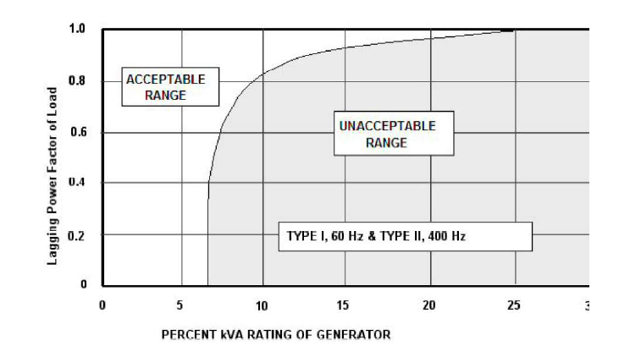
Figure 4: Acceptable region for pulsed loads: Pulsed Load Power Factor vs Pulsed Load Apparent Power percent of Generator Apparent Power (ANEP-100)
- Impact of pulsed loads on sources
  - Generator sets
Pulsed loads may negatively impact generator sets and system performance in several ways:
- The pulsed loads translate into torque pulsations, rapid thermal cycling, and steel lamination losses on the prime mover that can lead to metal fatigue as well as wear on the throttle valves.
- In the case of paralleled ac generator sets where the generator sets are not identical, differences in moments of inertia and throttle responsiveness can result in the smaller generator set transiently taking on more load than it is rated for and tripping off line.
- In ac systems, the torque pulsations may result in the generator set(s) not able to keep the system frequency within power quality requirements. Since the pulsed loads may occur often, the system frequency should be maintained within the normal frequency tolerance (not the frequency transient tolerance).
- The sudden application of load may lead to the voltage not meeting power quality requirements; the voltage regulators on the generator sets may not be able to react fast enough to the load change. Furthermore, cable inductance may transiently present larger voltage drops than under normal 60 Hz. Operation. Since the pulsed loads may occur often, the system voltage should be maintained within the nominal voltage tolerance (not the voltage transient tolerance).
  - Transformers
Pulsed loads may negatively impact transformers and system performance in several ways:
- Rapid thermal cycling, high transient electromagnetic forces, and core losses can degrade insulation.
- Transformer impedances may interact with the pulses such that the voltage waveform on the secondary does not meet steady-state or transient power quality requirements.
  - Power electronics converters
Power electronic converters with switching time periods significantly shorter than the pulse width should be capable of maintaining power quality at the converter output. The power electronic converters should have sufficient internal energy storage to ensure the load current waveform at the converter input also meets power quality requirements.
- Impact of pulsed loads on circuit protection
  - Differentiating from faults
Other than the initial inrush current when a pulsed load is brought online, the peak power of a pulsed load should not exceed the rated load. Hence circuit protection based on the rated load should be sufficient to protect against faults; faults should exceed the rated load for a period of time to exceed the I²t trip rating.
Large pulsed loads typically have a ramp rate limit; faults typically will exceed this ramp rate limit.
  - Differentiating from inrush current
While a pulsed load may experience an inrush current when initially brought online, the pulsed load’s current profile will typically have a more prolonged period at the peak value; inrush current usually reaches a peak value in a few milliseconds, then decays in milliseconds to seconds. Inrush current may also achieve levels that exceed the rated current; the I²t trip rating of the protective device is chosen to not trip based on the inrush current characteristics. Once online, the pulsed load current should not exceed its rated value. Pulsed loads may also have pulses with a duration long enough for the speed governor and voltage regulator to react to the change in power level.
Large pulsed loads may have their magnitude limited to the rated current; the pulses are often ramp rate limited while the inrush current is often not limited.
- Pulsed load mitigation
If analysis indicates power quality requirements may not be met due to the pulsed loads, a number of mitigation efforts are possible:
  - Energy storage
Energy storage fulfilling the function of ESM-F4 is a common means for mitigating pulsed loads. If a ship only has a few pulsed load, it may be beneficial to use an Uninterruptible Power Supply (UPS) style of energy storage. Each pulsed load has a dedicated UPS that serves as a buffer between the pulsed load and the power system. The UPS ensures the current at the power system interface meets power quality requirements as well as ensures the required pulse characteristics of the pulsed load are also met. The downside of this approach is that the energy within a given UPS cannot be shared among multiple pulsed loads. Furthermore, a failure within an UPS (if redundancy is not provided) precludes the use of the attached pulsed load.
A modified approach is to interconnect the outputs of multiple UPSs to form a pulse-power bus that is used to power multiple pulsed loads. This enables sharing of energy storage, but can be costly if sufficient redundancy is required to ensure continued operation following damage. This bus must have adequate fault protection that can successfully operate within the environment of significant pulses.
Another approach is to use energy storage systems that connect directly to the switchboards with attached pulsed power loads. All of the energy storage systems could potentially participate in response to a pulse; failure of a single energy storage system is not likely to preclude operation of any pulsed load. These distributed energy storage systems could also be used for power factor correction as well as harmonic current cancelation.
  - Power redirection
Certain loads, such as electric propulsion, can serve as power buffers; as long as the long-term average power is maintained, short term power demand can vary significantly. This enables propulsion (and other loads such as water heaters) to serve as virtual energy storage. When propulsion is operating at a power level at or above the peak pulse magnitude, power may be redirected from propulsion to the pulsed load to keep the power level provided by the generator set relatively constant. Power redirection however, is only effective when the load is drawing sufficient power; at other times energy storage or other methods should be employed. Power redirection has the advantages of prolonging the life of energy storage (reduces the number of charge-discharge cycles) as well prolonging the life of generator sets (reduces the impact of pulses on the prime mover and generator).
Power redirection is likely to be most successful if the pulsed load and the propulsion motor are connected to the same switchboard. By connecting to the same switchboard, the pulse is not conducted via bus-ties; voltage drops in the bus-ties may result in power quality issues.
  - Control negotiations
In cases where the pulsed load may not fully meet interface requirements, but the power system may still be capable of supplying power to the pulsed load without comprising system level power quality, control negotiations between the pulsed load and the power system may be sufficient to optimize performance of the pulsed load under the constraints of the power system capability. Doerry and Amy (2015) describe one such method of control negotiations for an MVDC shipboard power system with pulsed loads.
  - DC distribution systems
Having generator sets immediately rectify their ac power with active rectifiers to produce dc power for distribution can simplify the integration of pulsed power loads. By paralleling the generator sets at the dc interface, the generators are not required to maintain synchronism. When paralleled ac generator sets are subjected to a pulsed load, significant transient currents flow between the ac generator sets to create electromagnetic forces to keep the generator sets in synchronism. When paralleled on the dc interface, synchronism is not required; transient currents to enforce synchronism do not exist; and the smaller generator set is less likely to trip from a transient overload.
DC distribution systems also simplify the integration of energy storage systems. Energy storage systems can be configured with a droop characteristic featuring a no load voltage that is below the nominal system voltage and a full load voltage above the minimum steady-state voltage requirement; when the voltage sags due to a pulse, the energy storage automatically provides power to keep the load within steady-state voltage tolerances. When the system voltage approaches nominal system voltage, the energy storage recharges.
At the present time, there are no established standards for pulsed power loads within a dc system. A draft MVDC interface standard (Doerry 2020) that was never approved proposed a maximum current rate of change of 50 A / ms without control negotiations. At 12 kV, this translates to 600 MW / s. With control negotiations, the allowable ramp rate can be up to 6 GW/s. These ramp rates are orders of magnitude higher than allowed for large ac loads by MIL-STD-1399-300-1. The inductance of cables may prove to limit the maximum ramp rate that can be achieved. The feeder cables to the pulsed loads should connect directly to a generator set switchboard to limit the impact of the pulse on other loads.
- Pulsed load analysis
  - Determining if pulsed load meets interface requirements
Normally the manufacture of the pulsed load performs the analysis and testing to demonstrate conformance to a stated set of interface requirements. Since some of the interface requirements depend on the ratings of online generator sets, the ship power system designer should ensure these criteria are met.
In early-stage design, if the interface requirements are easily met, then one usually assumes the system can be successfully integrated. If the interface requirements are not met, if the interface requirements are close to not being met, or if it is unknown whether the interface requirements are met, then the ship power system designer should allocate space, weight, power and cooling (SWAP-C) for mitigation equipment.
The performance of the pulsed load with respect to interface requirements should be verified through testing as part of factory acceptance testing of the pulsed load, and/or as part of ship acceptance testing.
  - Determining if system is able to maintain power quality with pulsed load
Starting in preliminary and contract design (and possibly earlier), a detailed transient simulation should be performed to ensure the system is able to maintain power quality in the presence of pulsed loads without significantly degrading the life of power system components. Multiple scenarios should be crafted and simulated to cover the various operational situations that the ship may encounter. See Kanellos et al. (2006) and Steurer (2007) for examples of transient simulations. Andrus et al. (2013) provide guidance on modeling shipboard power system components for time domain simulation.
During early-stage design, if the pulsed loads do not or may not meet interface requirements, then performing detailed transient simulation may be warranted. Often the details of system design and power system equipment design are not known sufficiently in early-stage design to predict accurately the final system performance. The goal of the analysis should be to bound the level of mitigation efforts required to achieve acceptable performance; the end product is the SWAP-C that should be incorporated into the ship design for the mitigation efforts.
During preliminary-contract design, as more is known about the pulsed load and the power system, refined simulations should be performed to either verify that interface standards are likely to be met, or to develop requirements for mitigation efforts.
During detail design, the simulations should be refined again to reflect the actual equipment and systems installed on the ship; the effectiveness of mitigation efforts should be verified. Any deficiencies found should be corrected.
The simulations should include waveform level models of prime movers, speed governors, generators, voltage regulators, power conversion equipment, transformers, cables, and the pulsed loads. Because the transients are much faster than 60 Hz, models should incorporate actual inductances, capacitances, and resistances instead of impedances calculated at 60 Hz.
  - Determining impact of pulsed load on prime movers
The impact of pulsed loads on prime movers is typically not documented in datasheets. The original equipment manufacturer usually will not provide this level of detail without having a contract in place. Keeping the torque pulsations on the prime mover as low as possible through mitigation efforts helps mitigate this risk. If possible, a testing program should be conducted during preliminary design to characterize the impact of the pulsed loads on a specific prime mover.
- References
ANEP-100 (STANAG 1008), NATO Standard, Characteristics of Shipboard 440V/230V/115V 60Hz, 440V/115V 400 Hz and 24/28VDC Electrical Power Systems in Warships of the NATO Navies.
MIL-STD-1399-300-1, Department of Defense Interface Standard, Section 300, Part 2, Low Voltage Electric Power, Alternating Current.
MIL-STD-1399-300-2, Department of Defense Interface Standard, Section 300, Part 2, Medium Voltage Electric Power, Alternating Current.
Andrus, Mike, Matthew Bosworth, Jonathan Crider, Hamid Ouroua, Enrico Santi, and Scott Sudhoff, "Notional System Models", Electric Ship Research and Development Consortium Technical Report, Dec 2013.
Boehmer, Tyler and Deanna Temkin, "Power-Specification Frequency-Domain Test and Analysis Methodology for Large Dynamic Loads", Johns Hopkins University Applied Physics Laboratory, Laurel, MD, Rev 0, January 2, 2018.
Doerry, Norbert, and John Amy Jr., "MVDC Shipboard Power System Considerations for Electromagnetic Railguns," 6th DoD Electromagnetic Railgun Workshop, Laurel MD, Sept 15-16, 2015
Doerry, Norbert, "Preliminary Interface Standard, Medium Voltage Electric Power, Direct Current," Naval Sea Systems Command, Technology Office (SEA 05T), Ser 05T / 002 of 16 January 2020. Available from DTIC AD1090170
Kanellos, F.D., I.K. Hatzilau, J. Prousalidis, E. Styvaktakis, “Simulation of a Shipboard Electrical Network (AES) comprising Pulsed Loads”, Engine as a Weapon II, IMarEST, Dec. 2006, London.
Kanellos, F., I. K. Hatzilau, and J. Prousalidis, "Investigation of voltage-frequency modulation in ship electric networks with pulsed loads according to STANAG 1008 design constraints", Proceedings of All Electric Ship 2007, IMarEST and SEE, London UK, 25-26 September 2007.
Steurer M.; M. Andrus; J. Langston; L. Qi; S. Suryanarayanan; S. Woodruff; P.F. Ribeiro; "Investigating the Impact of Pulsed Power Charging Demands on Shipboard Power Quality", 2007 IEEE Electric Ship Technologies Symposium, Arlington VA, 21-23 May 2007, DOI: 10.1109/ESTS.2007.372104.
Tsekouras, George J., Fotis D. Kanellos, John M. Prousalidis and Ioannis K. Hatzilau, "Implementation Limitations of STANAG 1008 Design Constraints for Pulsed Loads", Nausivios Chora, A Journal in Naval Sciences and Technology, pp. 110-135, ISSN: 1791-4469, 2012 Hellenic Naval Academy.

